**FULL ADDER**

**EXP.NO: 23**

**AIM:**To design and implement the full adder using Logisim simulator.

**PROCEDURE:**

1)      Pick and place the necessary gates.

2)      Insert 3 inputs into the canvas.

3)      Connect the inputs to the XOR gate, AND gate and OR gate.

4)      Insert 2 outputs into the canvas.

5)      Make the connections using the connecting wires.

6)      Verify the truth table.

**TRUTH TABLE:**

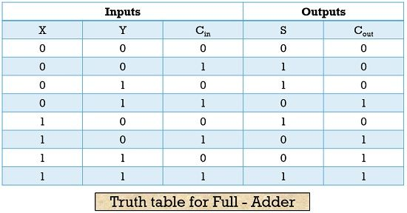  
  
  
  
Sum=(A⊕B) ⊕Cin

Carry=A.B+ (A ⊕B)

**OUTPUT:**

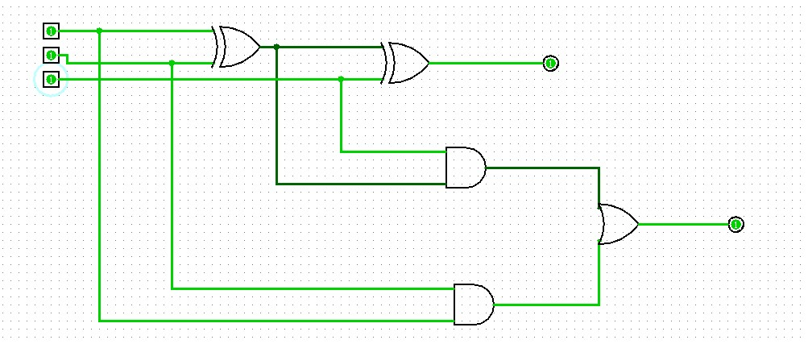  
  
  
  
  
**RESULT:**

Thus full adder has been designed and implemented successfully using logisim simulator.

Class comments.